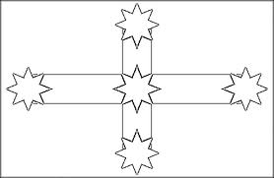
Tasks:
- Colour the flag
- What does the flag stand for?
________________________________________________________________________________________________________________________________________________________________________________________________________________________________________
- How would the diggers of all nationalities feel when they saw this raised flag?
______________________________________________________________________________________________________________________________________________________________________________
4. List all the things that the Ballarat Reform League were fighting for?

